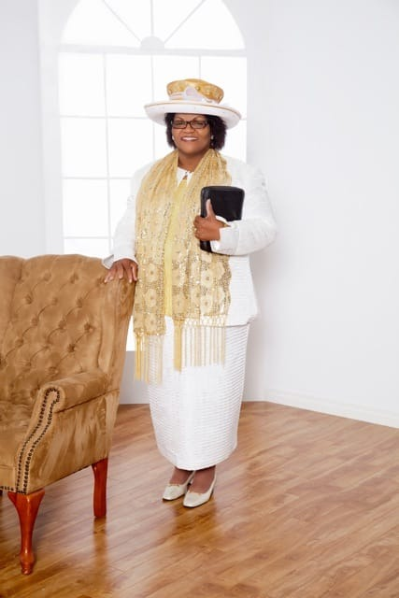

**Pastor Norma Sinclair Paul - Founder of Triumphant Ministries**

**Pastor Norma was raised within a strong Christian family but did not commit herself to the Lord for many years. It was in 1990 when she became very ill and as some would say “I've traveled deaths road”, was when Norma Sinclair decided to surrender her life to the Lord, choosing life over death.**

**My surrendering to the Lord came with a strong calling which I could not understand. I found myself questioning the Lord, asking him, why me? I soon realized, "thy will be done".**

**As I struggled to understand what was taking place in my life, the Lord was revealing himself clearly through visions and revelations which led me to start travelling. As I began travelling, the Lord led me into various ministries to work alongside pastors; I started to win souls for his kingdom. I then realized the Lord was preparing me for what was about to come next.**

**As my vision became more and more clear, the Lord revealed to me that one day I will have a ministry, and it will be called Triumphant Ministries. This became a conviction in my spirit over the years.**

**In 1992, I was strongly led to attend a Christian Institution for Theological Studies, and in 1994 I became a member of the Certified Evangelical Pastoral Counselors of America. After completion I returned to the U.S.A. where I served as an assistant Pastor for two years. I then returned to my home church in Canada where I continued serving, while the name 'Triumphant Ministries' became a constant reminder as to what the Lord was saying.**

**I proposed the name Triumphant Ministries to several people who were interested in ministry, asking them to use the name, but no one would take on that name. It started to become a burden in my spirit.**

**In 2002 I was led to Edmonton, someplace I had no desire to be. In obedience to the Holy Spirit and through seeking confirmation, I made the move. Rather than starting the ministry I started to attend a church thinking I could avoid my purpose for coming to Edmonton but the name would still remain in my spirit as a constant reminder as to why the Lord had brought me here.**

**In 2006, with encouragement from my husband, close friends and acquaintances we started prayer meetings in my home. In 2007 we became an incorporated ministry and moved our meetings into a school gymnasium where we started regular Sunday worship. In the beginning of 2008 we moved to our now present location at 6720 82 avenue.**

**Since starting this Ministry we have been blessed with faithful committed and dependable people, who are willing to serve the Lord. By God's grace and mercy, we continue to grow and triumph. (Now thanks be unto God, which always causes us to triumphant in Christ).**

**II Corinthians 2 verse 14.**

**Triumphant Ministries Staff Directory:**

Ian Johnson, Assistant Pastor

Martin Thompson, Evangelist

Daphne Campbell, Evangelist

Elene (Pam) Ricketts, Deaconess

Nicole (Nikki) Dalrymple, Deaconess

**Triumphant Ministries’ Programs:**

Children’s Sunday School

Adult Sunday School

Women’s Ministry

Prayer Meetings

Bible Studies

Family Training Hour (FTH)

Outreach Program, Beyond the Walls

**Triumphant Ministries Services**

Adult Sunday School 10:00 AM

Sunday Divine Service 11:00 AM

Children's Sunday School 12:00 PM

Ladies Ministries - 7:00 PM

On Zoom

Second and Fourth Tuesday's of each month

Next Meetings: June 14th and 28th

Wednesday Prayer - 7:00 PM

In Sanctuary and on Zoom ID 315-662-3531

Thursday Bible Study - 7:00 PM - On Zoom, ID 315-662-3531

Next Meeting: June 2nd and 9th

FTH (Family Training Hour)

Next Meeting: June 10, 2022

Fast and Prayer - 10:00 AM

Last Saturday of each month

First Sunday each month

Communion

Our Outreach Feed the Homeless Program

Next Outreach: June 18, 2022

Meeting for preparation 12:00 noon

Leave for downtown at 1:30 PM